**Ideation Phase**

**Define the Problem Statements**

|  |  |
| --- | --- |
| Date | 25 June 2024 |
| Team ID | SWTID1719938063 |
| Project Name | ShopEZ: E-Commerce Application |
| Maximum Marks | 3 Marks |

**Customer Problem Statement:**

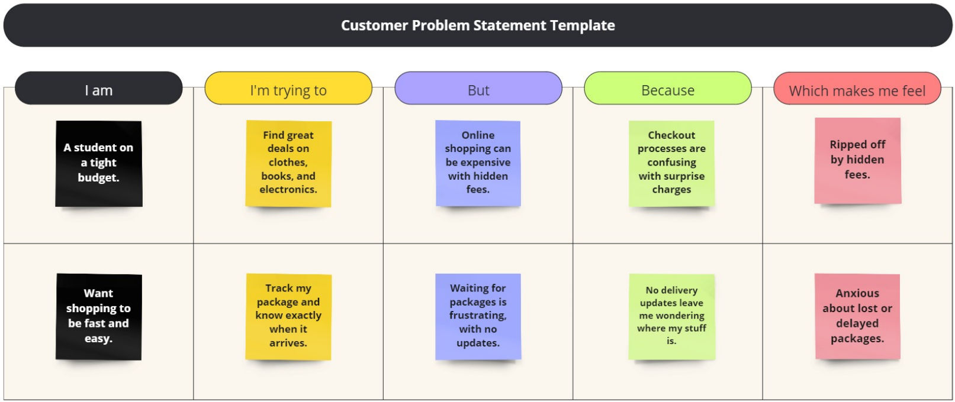

|  |  |  |  |  |  |
| --- | --- | --- | --- | --- | --- |
| **Problem Statement (PS)** | **I am (Customer)** | **I’m trying to** | **But** | **Because** | **Which makes me feel** |
| PS-1 | A student on a tight budget. | Find great deals on clothes, books and electronics. | Online shopping can be expensive with the hidden fees. | Checkout processes are confusing with surprise charges. | Ripped off by hidden fees. |
| PS-2 | Want shopping to be fast and easy. | Track package and know exactly when it arrives. | Waiting for packages is frustrating with no updates. | No delivery updates leave me wondering where my stuff is. | Anxious about lost or delayed packages. |